# 2IMV20 Visualization: Report Assignment 1

Lois Nijland (0860184), Joost Pieterse (0848231)

**Ray casting**

**MIP and compositing**

***Implementation MIP***

The implementation of maximum intensity projection uses large parts of the implementation of the slicer, which was already given. One difference is that we added a third nested loop which goes from 0 up to the maximum ray length, which is computed to be the length of the diagonal of the volume. This third loop is introduced for the following:

pixelCoord[0] = uVec[0] * (i - imageCenter) + vVec[0] * (j - imageCenter) + volumeCenter[0] + (k - maxRayLength / 2) * viewVec[0];

The part that is different from the slicer’s implementation is the last part: + (k - maxRayLength / 2) * viewVec[0]. We use this to obtain the entire vector (all the points along the vector), whereas before, in the slicer, you only had one point. A similar implementation is done for pixelCoord[1] and pixelCoord[2].

The variable val is computed to be the maximum of all getVoxel(pixelCoord) or getInterpolatedVoxel(pixelCoord) (this will be described in Section Tri-linear interpolation). By doing this we get the maximum value for each point and we use these values for the final image.

Another difference with slicer is that the RGB of the image is set slightly differently. Namely, we use a loop with variable k that goes from 0 to step (described in Section Responsiveness) and we use a nested loop with variable g that goes from 0 to step. We then do image.setRGB(i + k, j + g, pixelColor). This way we give every pixel along all the vectors their corresponding color. We only do this if (i + k < image.getWidth() && j + g < image.getHeight()), so that we do not exceed the image width or height.

The final difference between MIP and slicer is that some features were added for MIP to improve responsiveness. This is discussed in Section Responsiveness.

***Implementation compositing***

The implementation of compositing has only a few differences with MIP. We add a variable previousColor, which is initialized to be TFColor(0, 0, 0, 0). We do not use variable val anymore, instead we use variable alpha, which simply computes getVoxel(pixelCoord) or getInterpolatedVoxel(pixelCoord).

After this there is a new part, which is based on the “Front-to-Back” method for compositing. This method has the following formulas:

$$C_{out}= C_{in}+C\left(x\right)*α\left(x\right)*(1-α_{in})$$

$$α_{out}= α_{in}+α\left(x\right)*(1-α_{in})$$

We implemented this “Front-to-Back” method as follows:

TFColor color = tFunc.getColor(alpha)

And we do for variable red the following (using the Cout formula above with our variables):

double red = previousColor.r + color.r * alpha / max * (1 - previousColor.a)

previousColor.r = red

For green and blue we do the same with previousColor.g, color.g and previousColor.b, color.b respectively. For newAlpha, we also do the same with previousColor.a, but here we do not use the “color.x” (using the αout formula above with our variables).

Now we set the “voxelColor.x” to be the computed “previousColor.x”. So voxelColor.r = previousColor.r, and similarly for voxelColor.g, voxelColor.b and voxelColor.a.

***Pros and cons***

A pro of MIP is that it displays the “inside” of the image. As an example, take the visualization of a skull. Using MIP, you will be able to clearly see the bone structure and teeth for example. So, because of this property the visualization of particular objects is very clear.

A con of MIP occurs when you want to visualize an object that has approximately the same intensity everywhere. If this is the case, then everything will appear in approximately the same color, and thus it will be difficult to distinguish between various parts of the object.

A pro of compositing is that you can very clearly see the outline of an object. So in the case discussed in the previous part, where the object has approximately the same intensity everywhere, you will still be able to see what is visualized very clearly. Another pro of compositing is that you can use different colors to make it clearer what object is visualized. For example, take the cross section of a lime, a lemon, and an orange. Using the color green for the lime, yellow for the lemon, and orange for the orange immediately shows you which object is visualized. Whereas, if you would not be able to use colors, these objects become almost impossible to distinguish.

A con of compositing is that some details of an image can get lost. Take again the example of the visualization of the skull. Certain parts, such as the teeth, cannot be seen in the final image when using compositing.

***Results***

Multiple comparisons are made to illustrate the strong and weak points of both MIP and compositing.

Figure XXX shows that the visualization of the pig is clearer when using compositing. The pig’s ears and snout can be distinguished much better from the rest of the pig when compositing is used. Also the flower pattern on the pig’s body can be observed better. This confirms the weak point of MIP; when the intensity is approximately the same everywhere, it becomes difficult to distinguish between the various part of the image. However, the compositing method is not better than the MIP method on all aspects. Namely, (a) reveals some lighter parts (coins) at the bottom of the pig. This cannot be seen in (b).

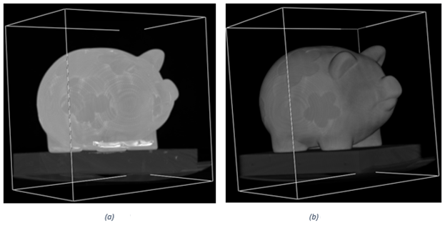

Figure Pig using (a) MIP and (b) Compositing

Figure XXX shows the difference between using MIP and compositing for the carp. These different techniques show different aspects of the carp. Figure XXX (a) visualizes the skeleton of the carp, whereas (b) and (c) visualize the outside of the carp. This illustrates the previously mentioned pro of MIP; it shows the “inside” of the carp. However, the outside of the fish, such as the head of the fish becomes less visible using MIP. In (b) and (c), the pro of compositing is shown; the outline of the carp is clearer.

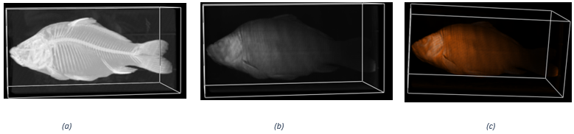

Figure Carp using (a) MIP, (b) Compositing, and (c) Compositing with colors

Figure XXX shows the top view of a backpack filled with different items. The difference between (a), (b) and (c) is not very large. In (a) the different items can be distinguished better than in (b) and (c). The items that are placed at the left, bottom and right sides are very similarly visualized. The items that are in the middle of the image become more blurry when using compositing instead of MIP. However, this does not happen when we use another angle to view the backpack, as can be seen in Figure XXX. This could indicate that some part of the backpack is blocking the view to the middle objects in Figure XXX (b).

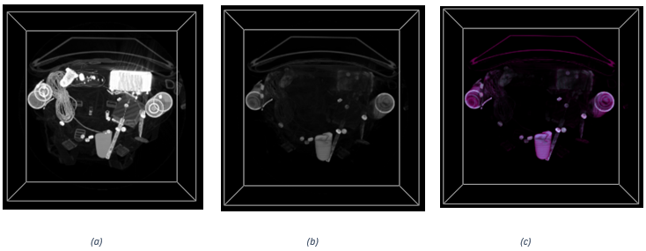

Figure Top view backpack using (a) MIP, (b) Compositing and (c) Compositing with colors

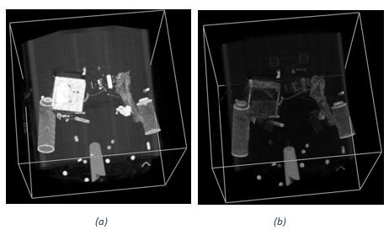

Figure Different view backpack using (a) MIP and (b) Compositing

Figure XXX visualizes a tooth. In (a) the tooth’s shape is clearly illustrated. The tooth appears to be in some kind of box; in (a) we see a grey box around the tooth. Remarkably (b) does not show any hint of what object is hidden in the grey box. This strongly illustrates the weak point of compositing, namely that some details of the image can get lost. In this particular case, the “detail” that gets lost is actually the most important part of the image.

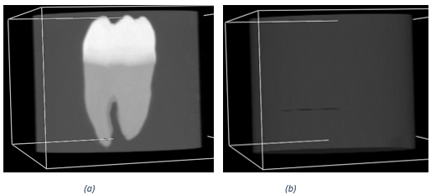

Figure Tooth using (a) MIP and (b) Compositing

Figure XXX visualizes a tomato. These visualizations show different aspects of the tomato. In (a) a cross section of the tomato can be seen. Figure XXX (b) and (c) display the outside of the tomato. The colored tomato illustrates the strong point of compositing mentioned above. Namely, the use of coloring can make it much clearer what is seen. For example, when you see (a) you will probably not immediately see that it is a cross section of a tomato. However, if you see (c) it is much more obvious that a tomato is shown.

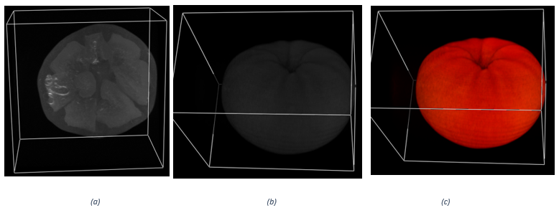

Figure Tomato using (a) MIP, (b) Compositing and (c) Compositing with colors

**Tri-linear interpolation**

***Implementation***

For the implementation of tri-linear interpolation we computed x0, x1, x2, x3, x4, x5, x6, x7 as in the picture given in the slides, which can also be seen in Figure XXX.

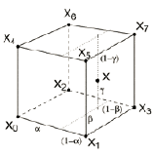

Figure Tri-linear interpolation model with points

To illustrate how exactly we computed these points, we show how we computed point x5:

int x5 = getVoxel(new double[]{pixelCoord[0] + 1, pixelCoord[1], pixelCoord[2] + 1})

The other points are computed similarly.

Then we compute alpha, beta and gamma. We do this as follows:

double alpha = pixelCoord[0] - Math.floor(pixelCoord[0])

This sets alpha to be the value after the decimal point of pixelCoord[0].For beta and gamma we use the same computation but instead of pixelCoord[0] we use pixelCoord[1] and pixelCoord[2] respectively.

Finally, we implemented the formula as given in the slides, namely:

$$S_{X}=\left(1-α\right)\left(1-β\right)\left(1-γ\right)S_{X_{0}}+α\left(1-β\right)\left(1-γ\right)S_{X_{1}}+\left(1-α\right)β\left(1-γ\right)S_{X_{2}}+$$

$$αβ\left(1-γ\right)S_{X_{3}}+\left(1-α\right)\left(1-β\right)γS_{X_{4}}+α\left(1-β\right)γS_{X_{5}}+\left(1-α\right)βγS_{X_{6}}+αβγS_{X_{7}}$$

Here we used the variables alpha, beta, gamma, x0 , x1, x2, x3, x4, x5, x6, x7, which we computed before.

***Results?***

**Responsiveness**

The raycaster becomes quite slow when using the application. To increase responsiveness during user interaction we introduced the so-called interactiveMode. This indicates whether there is a lot of user interaction. We check if this is the case, so if interactiveMode = true. If so, we will not use the tri-linear interpolation method and we increase the variable step to n, whereas before this was 1. By increasing it to n only 1 in each n values of a vector is read. This significantly increases responsiveness. However, since we now only look at one nth of the values, the resulting image will have a lower resolution. So, we had to make a tradeoff between responsiveness and the quality of the image. We did this by investigating different possibilities.

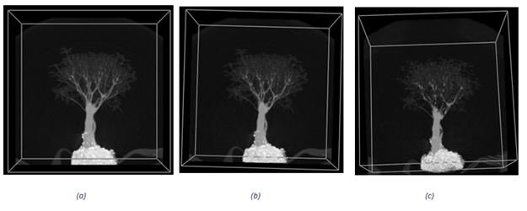

Figure In (a) step is 1, in (b) step is 4, in (c) step is 8

As can be seen in Figure XXX , the quality of images (a) and (b) does not differ very much, whereas image (c) differs significantly from image (a), particularly visible in the smaller branches of the tree at the top.

When interacting with these different step values, we found that the interaction of (a) is quite slow, the interaction of (b) is acceptable/okay and the interaction of (c) is somewhat faster than (b).

Therefore, we found that setting (b) gave the best resolution and interaction combination. So, we chose n to be equal to 4.

**2-D Transfer functions**

**Gradient-based opacity weighting**

***Implementation***

***Results***

**Extended triangle widget**

***Implementation***

***Results***

**Illumination model**

***Implementation***

***Results***

**Comparison of techniques**

Compare the results obtained from various data sets of the different approaches

The comparisons should clearly demonstrate the strengths and weaknesses of each of the techniques.

For “results”: the techniques should be applied to several data sets, interesting details in the data should be reported by showing a good set of transfer functions. The exploration process should involve extensive experimentation with the parameters of the various approaches.